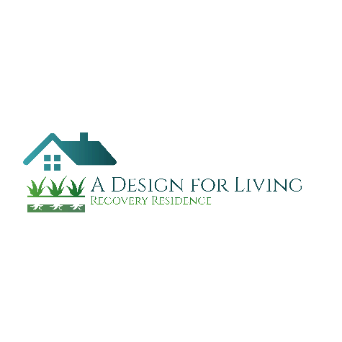
A Design for Living
Recovery Residence
Application

Name: ________________________________________________ Move In Date: _______________________
Today’s Date: ________________ D.O.B.__________________ Social Security #_______________________
Last known address: _________________________________________________________________________
Emergency Contact Name: _____________________ Phone: ________________ Relation: _______________
Insurance Company: ____________________________________________________________
I.D. #_____________________________ Group#:_____________________________________
IOP Name: ________________________________________ IOP Commitment Length:__________________

List all current medications
- ____________________________________________________________________________
- ____________________________________________________________________________
- ____________________________________________________________________________
- ____________________________________________________________________________

Allergies: _________________________________________________________________________________

Current legal Issues: _________________________________________________________________________
__________________________________________________________________________________________

Community Control: Yes ____ No ____

Probation: Yes___ No___ If yes, State: ____ Court date: ________ Probation Officer: _____________________
House Arrest: Yes ____ No ____

Drug of Choice: ____________________________________________________________________________

Clean/Sobriety Date: ______________________

Sponsor Name and Phone number: _____________________________________________________________

Number of times in treatment: ____________ Number of times in detox: ____________
Date of admit to most recent detox: ____________ Date of discharge from most recent detox: ______________
Have you ever been clean/sober before: Yes ____ No ____ If yes, Longest period of sobriety: ______________
List primary reasons for any relapses:
- ____________________________________________________________________________
- ____________________________________________________________________________
- ____________________________________________________________________________
- ____________________________________________________________________________
Have you ever been in a 12-step Fellowship? Yes ___ No ___ If yes, did you get a sponsor? Yes ____ No ____
If yes, were you open/honest with your sponsor? Yes ____ No ____ If not, Why? _______________________
__________________________________________________________________________________________
What suggestions given by your sponsor did you balk at the most? Why? _______________________________
__________________________________________________________________________________________
How far did you get working through the 12-steps? ________________________________________________

Do you believe in a Higher Power? Yes ____ No ____ Why or Why not? ______________________________
____________________________________________________________________________________________________________________________________________________________________________________
Have you ever had a therapist? Yes ____ No ____
If yes, were you open/honest with your therapist? Yes ____ No ____ If not, Why? _______________________
__________________________________________________________________________________________
What recommendations given by your therapist did you follow or not follow? Why? ______________________
__________________________________________________________________________________________

Do you have family support? Yes ____ No ____
Please elaborate: ____________________________________________________________________________
__________________________________________________________________________________________
Can we involve them in your recovery? Yes ____ No ____ Why or Why not? __________________________
____________________________________________________________________________________________________________________________________________________________________________________
What is you level of commitment to Recovery? Please elaborate: _____________________________________
__________________________________________________________________________________________
____________________________________________________________________________________________________________________________________________________________________________________
Are you willing to follow suggestions? Yes ____ No ____
Are there any suggestions you are NOT willing to follow? Yes ____ No ____ Why or Why not? ___________
____________________________________________________________________________________________________________________________________________________________________________________
Do you understand that participation in your own recovery to the best of your ability, while residing at A Design For Living is mandatory? Yes ____ No ____
Do you understand that failing to do so will result in you being discharged? Yes ____ No ____
What are your Goals for the next six (6) months?
- ____________________________________________________________________________
- ____________________________________________________________________________
- ____________________________________________________________________________
- ____________________________________________________________________________
- ____________________________________________________________________________
- ____________________________________________________________________________
List some long-term goals or aspirations:
- ____________________________________________________________________________
- ____________________________________________________________________________
- ____________________________________________________________________________
A Design for Living Staffs Goals for resident for the next six (6) months:
- ____________________________________________________________________________
- ____________________________________________________________________________
- ____________________________________________________________________________

What is your expectation of A Design for Living? _________________________________________________
______________________________________________________________________________________________________________________________________________________________________________________________________________________________________________________________________________

What do you hope to achieve during your stay at A Design for Living? ________________________________
____________________________________________________________________________________________________________________________________________________________________________________

How can we help you reach this goal?
______________________________________________________________________________________________________________________________________________________________________________________________________________________________________________________________________________

_______________________________ Date: ________________________
Resident Signature

_______________________________ Date: ________________________
Staff Signature

_______________________________ Date: ________________________
Director Signature

