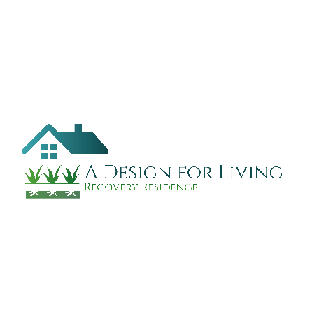
A Design for Living
Recovery Residence

Commitment Statement

- I recognize my need for a safe recovering environment and am applying for residency at A Design for Living.
- I agree and intend on maintaining residency with A Design for Living for a minimum of 6 months. I understand this is to ensure the stability of the house and enforce a sincere desire to live a sober life. I agree to provide a 2-week notice prior to departure date.
- I understand that I am a tenant at A Design for Living and answerable to such as landlords.
- I agree for myself, heirs, my assigned, that should an accident occur involving personal injury to myself or loss or damage to my personal property during my residence at A Design for Living, I agree to indemnify and hold harmless the management, owners or A Design for Living, as a whole from any and all liability in connection therewith.
- Any property left upon my departure and not claimed with in five (5) days either by myself or my authorized representative shall become the property of A Design for Living.
- I understand my continued residency at A Design for Living is dependent on my need and willingness to work and to help myself improve my quality of life.
- I agree to remain a drug and alcohol-free resident of A Design for Living for a minimum of six (6) months.
- I may be subject to dismissal for willful misconduct, which is deemed harmful to the reputation and best interest of A Design for Living or it residents. Dismissal will be immediate.
- I agree to adhere to all rules and expectations
My signature indicates I have read and understand the rules and that I am willing to make the described commitment to myself and to A Design for Living Recovery Residence.

_______________________________ Date: ________________________
Resident Signature

_______________________________ Date: ________________________
Staff Signature

_______________________________ Date: ________________________
Director Signature

