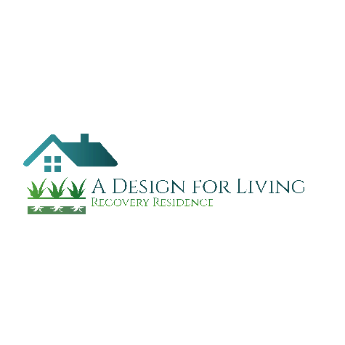
A Design for Living
Recovery Residence

Residency Agreement

Initial move in cost are $450.00 this covers:
First week = $225.00
Non-Refundable deposit = $225.00
Weekly rent $225.00 per week due at the house meeting

- I agree to keep the rented space in the same or better condition as when rented to me.
- I agree to abide by all other signed and not signed agreements as a condition of my residency at A Design for Living.
- Rent is to be paid in advance at the house meeting.
- Failure to maintain any agreement is ground for dismissal.
- I understand that no portion of the above mentioned cost will be returned if I am asked to leave.
The last week rent will be used solely as rent if:
- You have completed your six month commitment and given 2 week notice that you are moving.
- You have done no damage to A Design for Living property or any co-tenant property
- You have remained clean/sober your entire stay
- You have not been administratively discharged
- You have returned all house keys and property of “A Design for Living”

My signature indicates that I have read and understand the rental agreement and agree to adhere to its terms.

_______________________________ Date: ________________________
Resident Signature

_______________________________ Date: ________________________
Staff Signature

_______________________________ Date: ________________________
Director Signature

